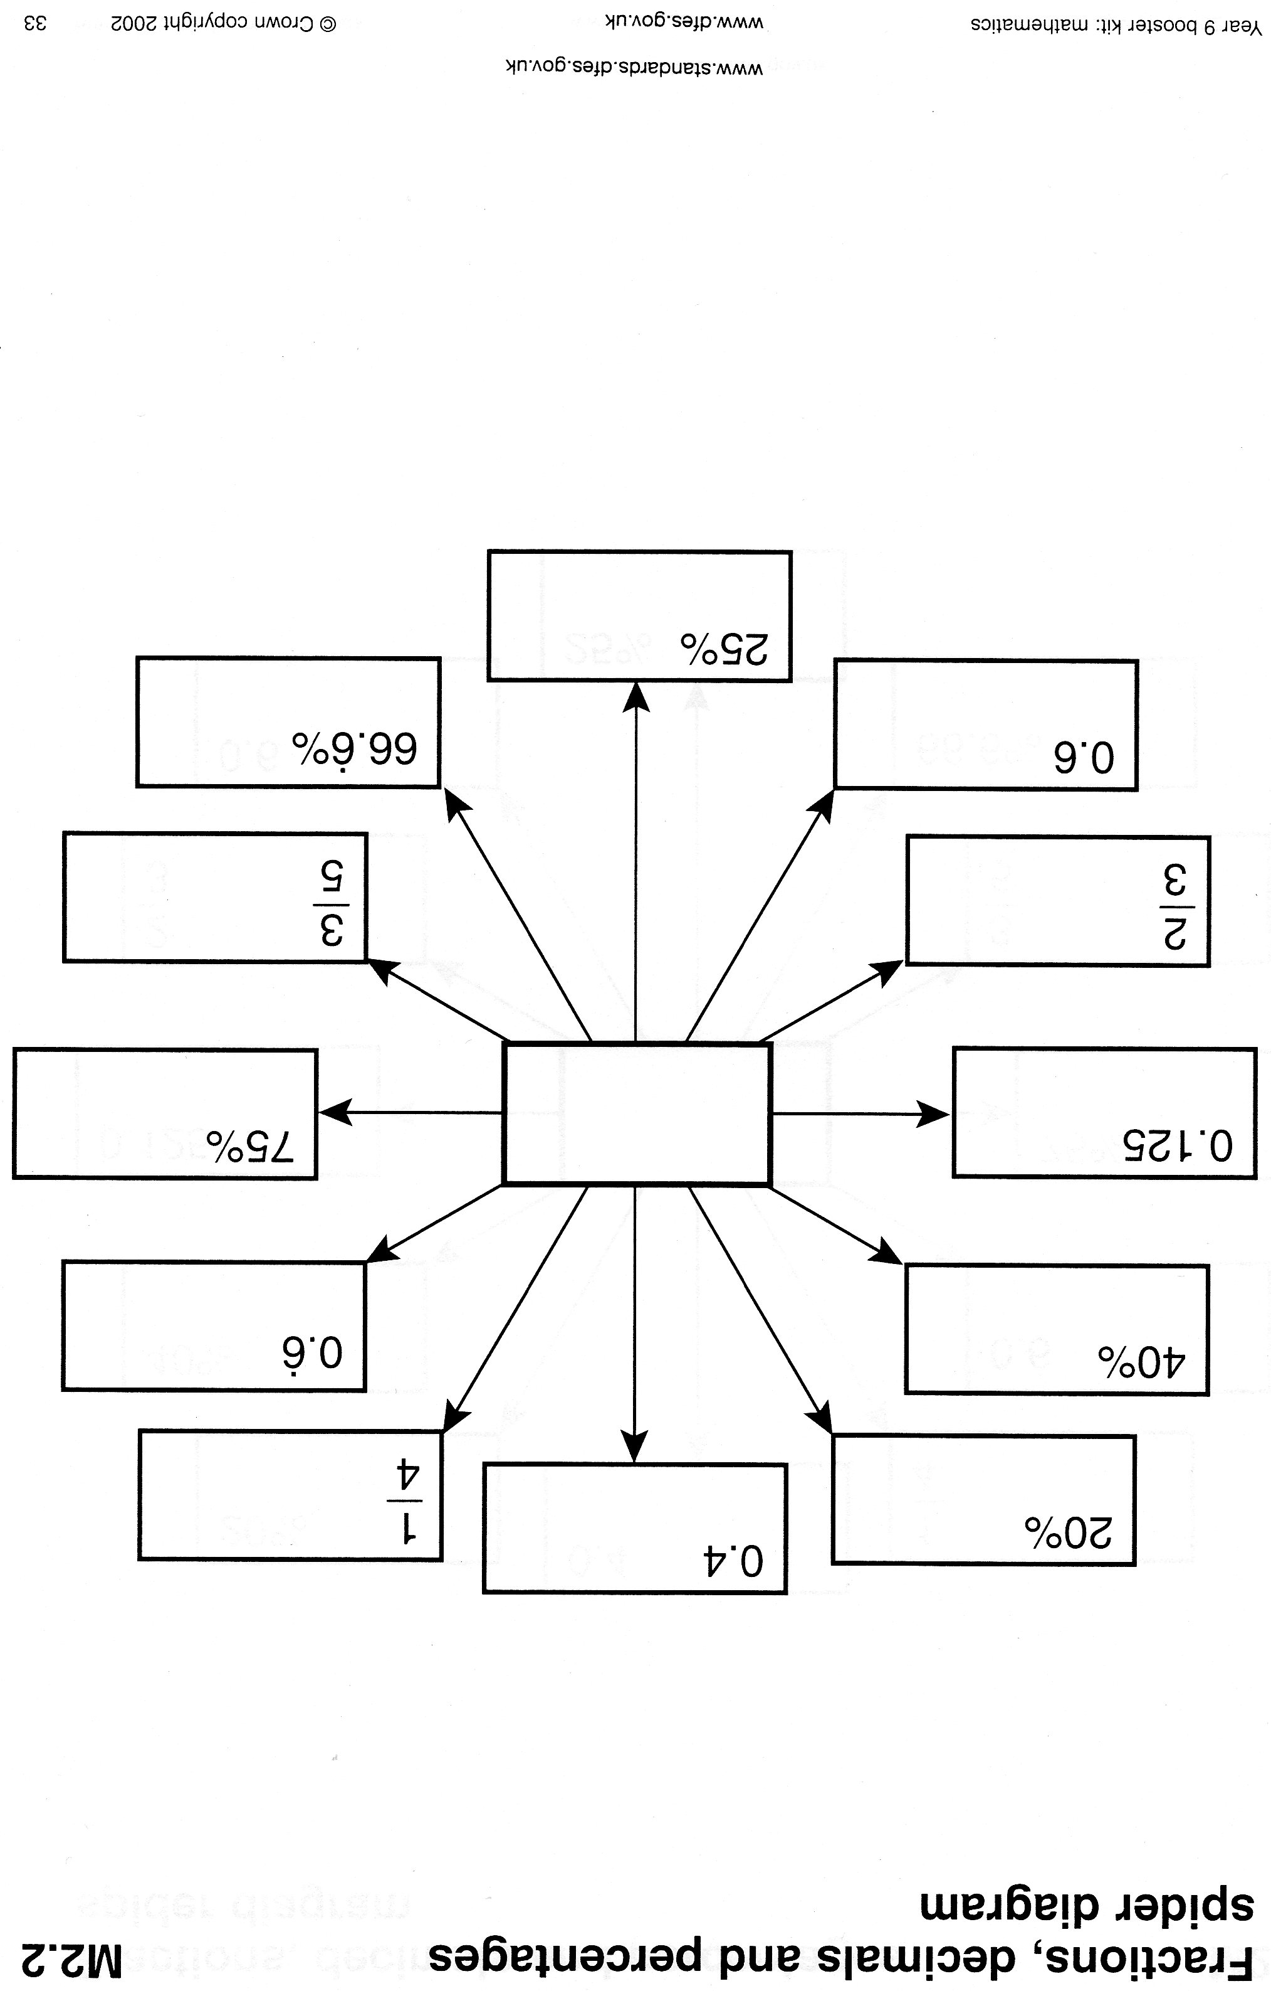
(2x - y)³ =

5xy =

(x + y)³ =

2x³ =

x³ =

2y² =

(3x - y)² =

3x² – 1 =

3x – y² =

(2x)³ =

2x² =

(2x)² =

x = -2
y = 3
(2x - y)³ =

6xy =

(x - y)³ =

2x³ =

x³ =

2y² =

(3x + y)² =

4x² – 1 =

4x – y² =

(2y)³ =

3x² =

(3x)² =

x = -1
y = -2

